Postage
Stamp

What Else should I know?
Payment
The cost per brick is $100

Sample Inscriptions

THE SMITH DAVID WHITE
FAMILY AUGUST 10, 1984

IN MEMORY OF ROCKY
WILLIAM JONES 1984 - 1995

IN HONOR OF PUFF THE CAT
FRED JOHNSON LOVE U 4EVER

Special Note
Please review your application carefully before mailing to ensure your engraving information is spelled correctly.


mailing instructions
Please mail your completed application form and a check or money order payable to:

Princeton/Pettoranello Foundation Inc.
120 John Street, Suite 3
Princeton, NJ 08542-3121

qUESTIONS
For more information, please call:

Eleanor Pinelli, President
Princeton/Pettoranello Foundation
609-921-7911

Thank you for your
contribution and participation!

Princeton/Pettoranello Sister-City Foundation, Inc.
120 John Street, Suite 3
Princeton, NJ 08542-3121

Princeton/Pettoranello Foundation
“Leave A Legacy –
Buy A Brick”
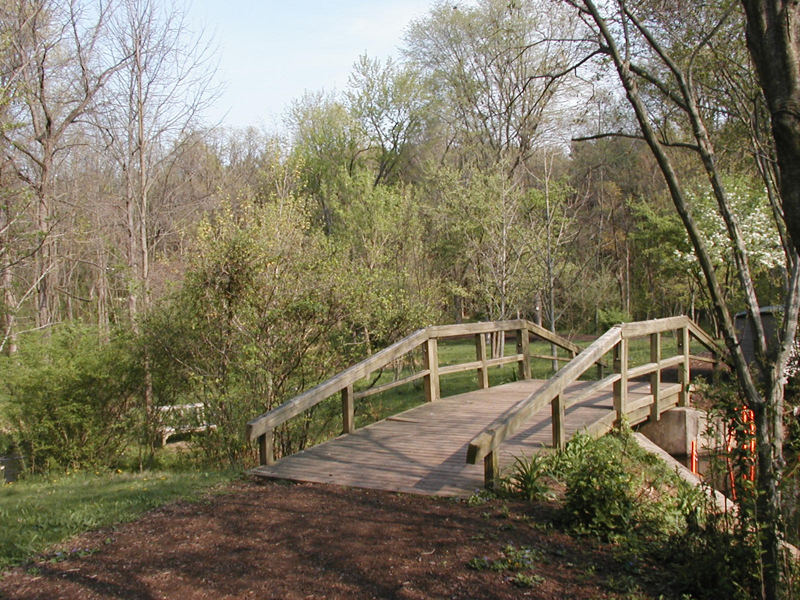

Pettoranello Gardens
Princeton, NJ

Enduring Memorial Etched in Stone
Sunday, June 17 – Thursday, June 21
2007

Building the future…

honoring the past

Community service
Pettoranello Gardens is a park beautification volunteer project of the Princeton/Pettoranello Foundation, a non-profit organization founded in recognition of the contributions by Americans of Italian descent to the quality of life in Princeton, NJ. The Foundation’s motto is to “Provide enduring Community Service”.

The site of Pettoranello Gardens located in Community Park North was once an overgrown neglected park. With years of work from volunteers and with total cooperation from the Princeton Recreation Department and the Department of Public Works, this 13- acre property today is a beautiful park enjoyed by many residents of Princeton and the surrounding area. The Foundation received the Community Recognition Award of the Princeton Task Force on Ethics and it won the NJ Park Association Award.

Future success
Continued beautification
The Princeton/Pettoranello Foundation invites you to support the continued beautification of Pettoranello Gardens by purchasing a commemorative brick. When you designate a brick, you create a timeless tribute, which will be displayed in the amphitheatre walkway.

help us pave the way
_ _ _ _ _ _ _ _ _ _ _ _ _ _ _ _ _ _ _ _ _ _ _ _ _ _ _ _ _ _ _ _ _ _ _ _ _ _ _ _ _ _ _ _ _ _ _ _ _ _ _ _ _ _ _ _ _ _ _ _ _ _ _ _ _ _ _ _ _

In the Amphitheatre
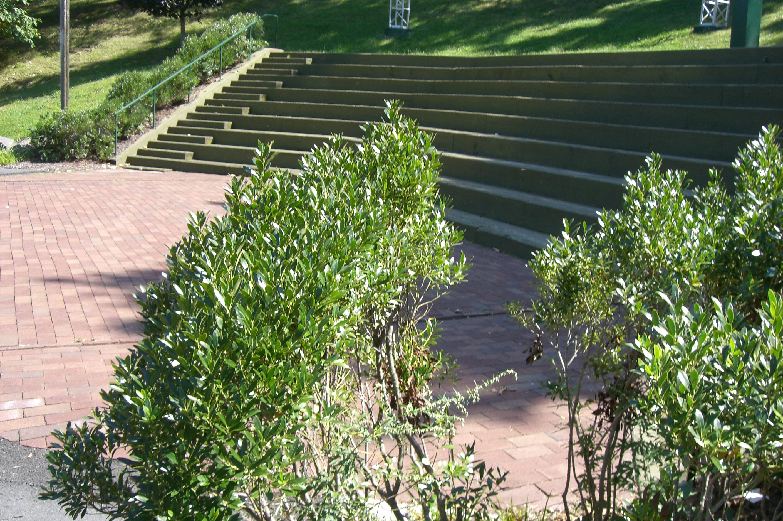
Pettoranello Gardens
Community Park North, Princeton, NJ

The “Leave A Legacy – Buy A Brick” fundraiser is a special way to bestow honor upon a loved one, relative, friend, or a special moment in your own life.


Take your permanent place in pettoranello gardens

Timeless tribute
- Complete order form for engraving (limit is 3 lines with 13 characters per line), spaces between words, commas and periods count as a single character,

- Print neatly (engraving will be centered in the allotted space), and

- If you are sponsoring more than one brick, please make copies of this form or call us for additional forms.

Memorial Brick Order Form
(Please Print)
Donor Name: ________________________________
Address:
________________________________
City:
________________________________
State: ______________ Zip:_________
Telephone:
(_____) _________________________
Email: ________________________________
Notify the following person(s) of this gift:
Name:
________________________________
Address:
________________________________
City:_____________________________
State: ______________ Zip: __________

4” X 8” Brick – Cost is $100 per brick
Inscription – Print one character per box

